EMCH 290-001-Quiz #4 Solutions Thursday, October 20th, 2022 Chapter #4
Points Possible: 100
If unit conversion is unclear, ask TA/professor. Box in ALL final answers!

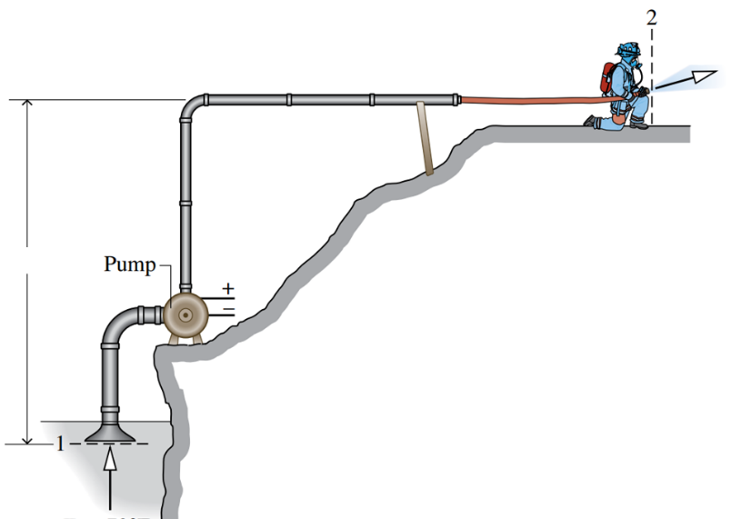
- Question 1(30 Points)
A pump steadily draws water from a pond at a volumetric flow rate of 0.015[$\frac{m^{3}}{s}$] through a pipe having a 0.25[m] diameter inlet. The water is delivered through a hose terminated by a converging nozzle. The nozzle exit has a diameter of 0.025[m] and is located 10[m] above the pipe inlet. Water enters at 20°C, 1 [bar] and exits with no change in temperature or pressure. The rate of heat transfer is 5% of the power input.
Use Eq 2, 3
- Determine specific volume from Table A-2
- Determine mass flow rate
- Determine the velocity of the water at the inlet and exit, each in m/s,
- Determine change in enthalpy [Note: No change in pressure/temperature]
- Determine the power required by the pump, in kW

- From Table A-2, $v=0.0010018$
- $\dot{m}=\frac{A_{1}V_{1}}{v_{1}}=\frac{0.015}{0.0010018}=14.97\left[\frac{kg}{s}\right]$
- $V_{1}=\frac{\dot{m}v}{A_{1}}=\frac{14.97*0.0010018}{π*\frac{{0.25}^{2}}{4}}=0.3055\left[\frac{m}{s}\right]$
- $V_{2}=\frac{\dot{m}v}{A_{2}}=\frac{14.97*0.0010018}{π*\frac{{0.025}^{2}}{4}}=30.55\left[\frac{m}{s}\right]$
- $h_{1}-h_{2}=0$
- $Q=0.05W→{\dot{W}}_{cv}=$ $\frac{\dot{m}}{0.95}\left(\left(h_{1}-h_{2}\right)+\frac{\left(\frac{V_{1}^{2}-V_{2}^{2}}{2}\right)+g\left(ΔZ\right)}{1000}\right)$
${\dot{W}}_{cv}=$ $\frac{14.97}{0.95}\left(0+\frac{\left(\frac{{0.3055}^{2}-{30.55}^{2}}{2}\right)+9.8\left(-10\right)}{1000}\right)=-8.89 kW$

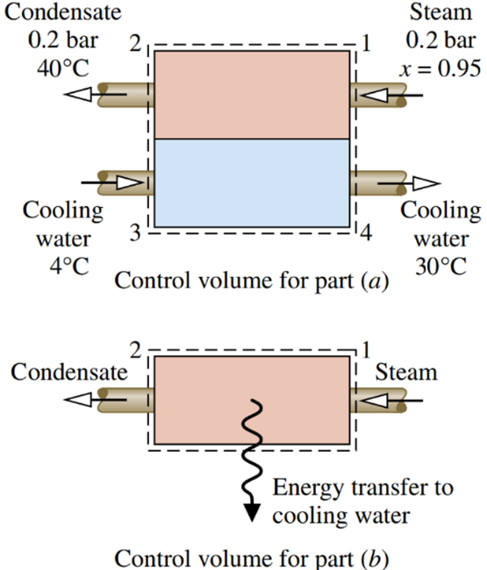
- Question 2(20 Points)
Steam enters the condenser of a vapor power plant at 0.2 bar with a quality of 0.90 and condensate exits at 0.2 bar and 40°C. Cooling water enters the condenser in a separate stream as a liquid at 4°C and exits as a liquid at 30°C with no change in pressure. W, KE and PE are negligible.
Use Eq 1, 3, 5
- Determine the ratio of the mass flow rate of the cooling water to the mass flow rate of the condensing steam.
  - Determine h₁ with quality from Table A-3
  - Determine h₂, h₃, h₄ from Table A-2
  - Determine ratio of mass flow rate

- The energy transfer (enthalpy change) from the condensing steam to the cooling water, in kJ per kg of steam passing through the condenser.

- $0={\dot{m}}_{1}\left(h_{1}-h_{2}\right)-{\dot{m}}_{3}\left(h_{3}-h_{4}\right)→\frac{{\dot{m}}_{3}}{{\dot{m}}_{1}}=\frac{h_{1}-h_{2}}{h_{4}-h_{3}}$
- $h_{f}$= 251.4 kJ/kg and $h_{g}$ = 2609.7 kJ/kg,
- $h_{1}=251.4+0.9\left(2609.7-251.4\right)=2373.87\left[\frac{kJ}{kg}\right]$

- $h_{2}=167.57;h_{3}=16.78; h_{4}=125.79$

- $\frac{{\dot{m}}_{3}}{{\dot{m}}_{1}}=\frac{2373.87-167.57}{125.79-16.78}=20.24$

- ${\dot{Q}}_{cv}+{\dot{W}}_{cv}={\dot{m}}_{1}\left(\left(h_{2}-h_{1}\right)+\frac{V_{1}^{2}-V_{2}^{2}}{2}+g\left(z_{1}-z_{2}\right)\right)$
- ${\dot{Q}}_{cv}={\dot{m}}_{1}\left(h_{2}-h_{1}\right)$
- $\frac{{\dot{Q}}_{cv}}{{\dot{m}}_{1}}=h_{2}-h_{1}=125.79-2373.87=-2248.08\left[\frac{kJ}{kg}\right]$

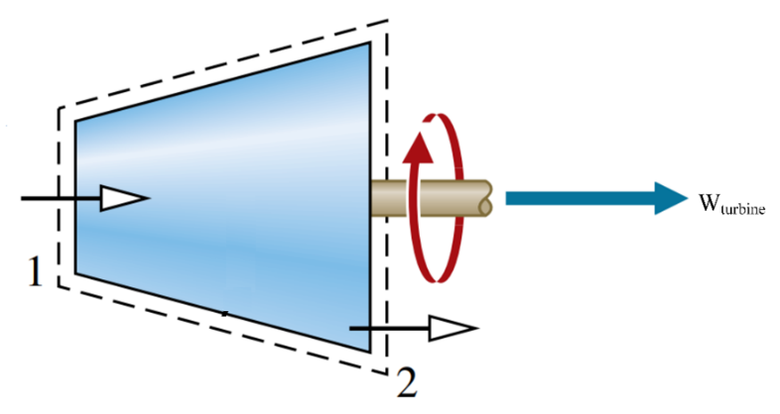
- Question 3(30 Points)
Steam flows steadily through an adiabatic turbine. The inlet conditions of the steam are 4 MPa pressure, 500 ˚C temperature, and 80 m/s velocity and the exit conditions are 50 kPa, 90% quality, and 50 m/s. The mass flow rate of the steam is 12 kg/s.
Use Eq 1, 2, 4, 5
Determine:
- Change in KE.
- Enthalpy at inlet from Table A-4
- Enthalpy at exit from Table A-3
- Power Output
- Determine specific volume at inlet from Table A-4
- Turbine inlet area

$$KE=\dot{m}\frac{\left(V_{1}^{2}-V_{2}^{2}\right)}{2}=12*\frac{{80}^{2}-{50}^{2}}{2}=23400 J=23.4 kJ$$
- $h_{1}=3445.3 \left[\frac{kJ}{kg}\right]$
- $h_{f}=340.49;h_{g}=2645.9;h_{2}=340.49+0.90\left(2645.9-340.49\right)=2415.359\left[\frac{kJ}{kg}\right]$
- $\dot{W}=\dot{m}\left(h_{1}-h_{2}+\frac{V_{1}^{2}-V_{2}^{2}}{2}\left(\frac{1}{1000}\right)\right)$
- $\dot{W}=12\left(3445.3-2415.359\right)+23.4=12382.7 kW$
- $v=0.08643\frac{m^{3}}{kg}$
$$v=\frac{A*V}{\dot{m}}→A=\frac{\dot{m}*v}{V}=\frac{12*0.08643}{80}=0.0129645m^{2}$$

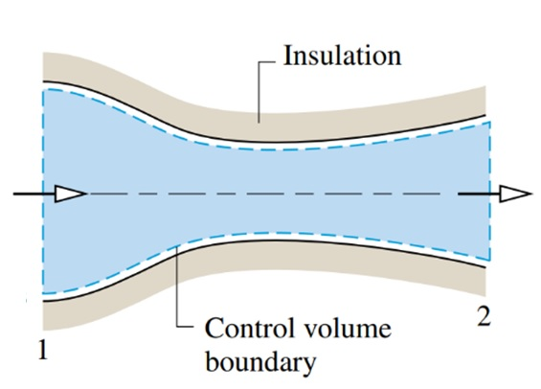
- Question 4(20 Points)
Steam enters a converging–diverging nozzle operating at steady state with p₁ = 140 [bar], T₁ = 400°C, and a velocity of 10 [m/s]. The steam flows through the nozzle with no change in PE, Q, W. At the exit, p₂ = 40 [bar], and the velocity is 700 [m/s]. The mass flow rate is 2 [kg/s].
Use Eq 1, 2
- Determine h₁ & h₂ & v₂ from Table A-4
- Determine the exit area of the nozzle, in [$m^{2}]$.

From Table A-4, $h_{1}=3001.9\left[\frac{kJ}{kg}\right]$
$$0=\left(h_{1}-h_{2}\right)+\left(\frac{V_{1}^{2}-V_{2}^{2}}{2}\right)→$$
$$h_{2}=3001.9\left[\frac{kJ}{kg}\right]+\frac{{10}^{2}-{700}^{2}}{2}\left[\frac{m^{2}}{s^{2}}\right]*\left[\frac{1N}{1kg⋅\frac{m}{s^{2}}}\right]*\left[\frac{1kJ}{{10}^{3}N⋅m}\right]=2756.95\left[\frac{kJ}{kg}\right]$$
From Table A-4, $v_{2} =0.07341\left[\frac{m^{3}}{kg}\right]$
$$A_{2}=\frac{\dot{m}v_{2}}{V_{2}}→A_{2}=\frac{2*0.07341}{700}=20.9{cm}^{2}$$

- ${\dot{Q}}_{cv}+{\dot{W}}_{cv}=\dot{m}\left(\left(h_{1}-h_{2}\right)+\left(\left(\frac{V_{1}^{2}-V_{2}^{2}}{2}\right)+g\left(z_{1}-z_{2}\right)\right)\frac{1}{1000}\right)$ The 1000 is used in metric.
- $\dot{m}=\frac{AV}{v}→V=\frac{\dot{m}v}{A}→A=\frac{\dot{m}v}{V}$
- $\dot{Q}+\dot{W}=∑{\dot{m}}_{i}\left(h_{i}+\frac{V_{i}^{2}}{2}+gz_{i}\right)-∑{\dot{m}}_{e}\left(h_{e}+\frac{V_{e}^{2}}{2}+gz_{e}\right)$
- $KE=\dot{m}\frac{\left(V_{1}^{2}-V_{2}^{2}\right)}{2}$
- $h=h_{f}+x\left(h_{g}-h_{f}\right)$

